

# FINANCE VERSION 2.0?

## Andrew G Haldane

Joint Bank of England/London Business School Conference on “*Is there an industrial revolution in financial services?*”

7 March 2016

# The “FinTech” Phenomenon

Index 2016=100

120

100

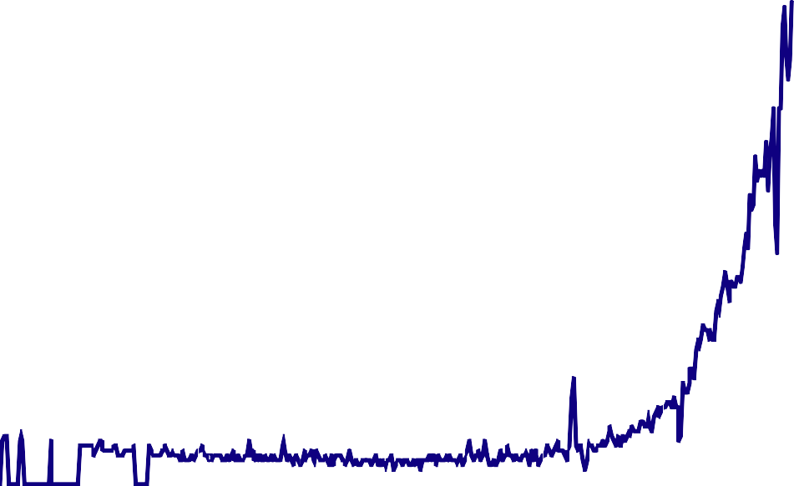

80

60

40

20

0

2004 2005 2007 2009 2011 2013 2015

Source: Google Analytics. Notes: Chart shows an index of the number of google searches for the term “FinTech”.

# Selected Recent FinTech Reports

* World Economic Forum:
  + *“The Future of Financial Services: How disruptive innovations are reshaping the way financial services are structured, provisioned and consumed”*
  + *“The Future of FinTech A Paradigm Shift in Small Business Finance”*
* Government Office for Science:
  + *“FinTech Futures: The UK as a World Leader in Financial Technologies”*
* European Central Bank
  + “*Virtual Currency Schemes – a further analysis”*
* ECUREX with Deutsche Bundesbank
  + *“Digital Currencies: Principles, Trends, Opportunities, and Risks”*
* Committee on Payments and Market Infrastructure:
  + *“Digital Currencies”*
* McKinsey:
  + *Annual Global Banking Reviews 2014 and 2015*
* Accenture:
  + *“The Future of Fintech and Banking: Digitally disrupted or reimagined?”*
* Ernst and Young (commissioned by UK Trade & Investment)
  + *“Landscaping UK Fintech”*
* BNY Mellon
  + *“Innovation in Payments: The Future is Fintech”*

# The “FinTech” Problem

## “The most important financial innovation that I have seen the past 20 years is the automatic teller machine.”

### Paul Volcker, December 2009

**New Financial Technologies**

* Finance is a market in information – information technology should matter!
* Distributed/peer-to-peer model
  + world wide web, second-hand goods, publishing, music, taxis, accommodation etc
  + massive productivity improvements in cutting out the middle person
  + reduced trading times, cutting costs, widening access

### Big data in this distributed network

* + pricing/marketing using granular data

# Cost of Bank IT Systems

Total IT spending as % of revenues or gross output

IT costs as % of revenues for European Banks

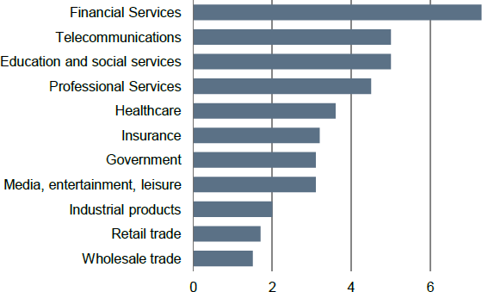 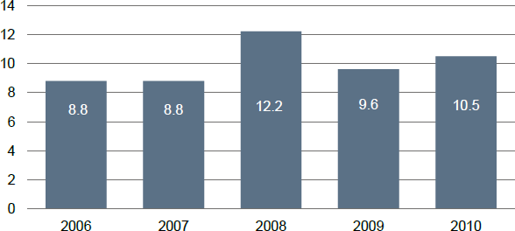

Source: Deutsche Bank (2012), “*IT in Banks: What does it cost?*”; Boston Consulting Group; Forrester Research inc.

# The “Sharing Economy” - AirBnB

* + Averages 425,000 guests per night, totaling more than 155 million guest stays annually — nearly 22% more than Hilton Worldwide.
  + Valuation exceeds well-established global hotel chains like Hyatt.
* 76% of Airbnb properties are actually outside the main hotel districts, suggesting complementarity of their offering.
* Although also likely to have an impact on hotel industry. Recent study suggested an 8-10% impact on other hotels’ revenues in Texas.

Sources: Byers and Zervas (2016), “*The Rise of the Sharing Economy: Estimating the Impact of Airbnb on the Hotel Industry*”; Finley (2013), “*Trust in the sharing economy*”; PWC (2015), “*The sharing economy*”.

# The “Sharing Economy” - Uber

* + Over one million rides on a daily basis. Market valuation now higher than Ford and General Motors
  + Cheaper than conventional taxi’s in most US cities, even excluding tips
  + Surge pricing algorithm to equilibrate supply and demand
  + Several taxi firms copied their business model – “Uberification”
  + Key feature in both is the ability to harness consumer feedback and build trust in the system.

Sources: Hall et al (2016), “*The effects of Uber’s surge pricing*”; Finley (2013), “*Trust in the sharing economy*”; PWC (2015), “*The sharing economy*”, Forbes (2015), “*At $68 Billion Valuation, Uber Will Be Bigger Than GM, Ford, And Honda”*.

# Uber’s Surge Pricing

Surge Pricing in Action - March 21, 2015

Ariana Grande sold out show at Madison Square Garden

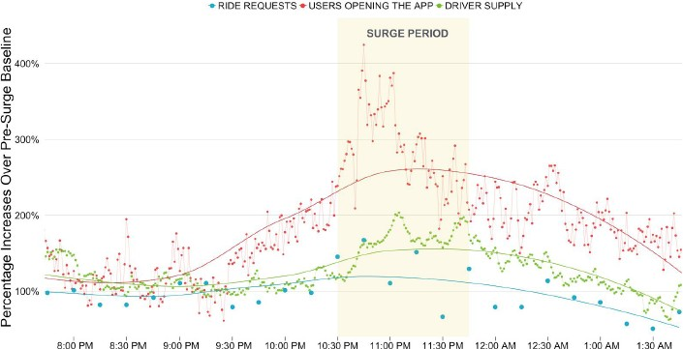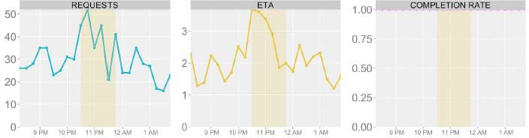

Source: Hall et al (2016), “*The effects of Uber’s surge pricing*”.

# Changing the Nature of Work

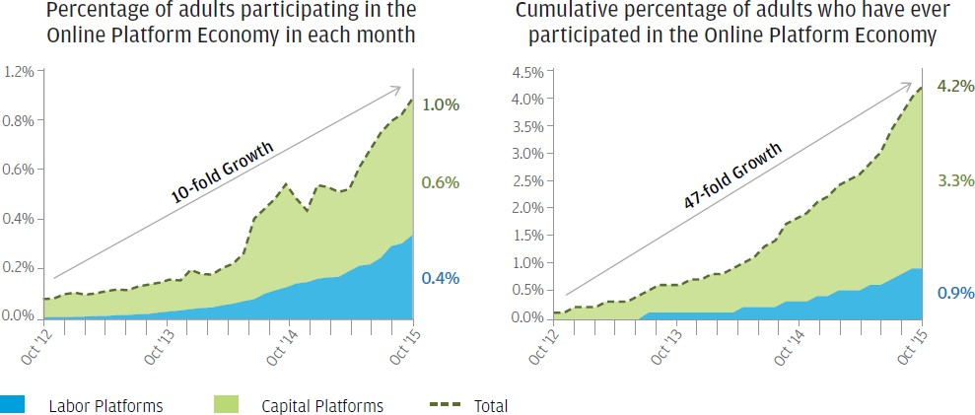

Source: JP Morgan Chase Institute (2016), “*Paychecks, Paydays, and the Online Platform Economy*”.

* Data from 1 million US Chase bank accounts show a large rise in income generated from online platforms, such as: Uber, AirBnB, Ebay.

# Why it Might Matter for Finance

### Stability of financial system

* + New entrants = diverse ecosystem

### Efficiency of financial system

* + Lower margins + higher volumes = higher productivity

### Democracy of financial system

* + Greater access + lower cost = social value

# Stability of Financial System

Incidence of Banking Crises

Banking Crises

All Crisis Types

Percentage of countries

90

80

70

60

50

40

30

20

10

0

1850 1870 1890 1910 1930 1950 1970 1990 2010

Sources: Reinhart and Rogoff (2011), updated and extended version of dataset constructed by Lane and Milesi-Ferretti (2007) and Maddison (1995). For further details see Haldane (2014), “*Managing global finance as a system”.*

Global Banks – Scale and Complexity

|  |  |
| --- | --- |
| Size of Balance Sheet | Nominal Value of Derivatives |
|  |  |
| Number of Legal Entities | Trading Assets (% of Total Assets) |
|  |  |

Sources: SNL Financial, FDIC, bank annual reports, Bank calculations. Notes: For further details please see Haldane (2015), “*On microscopes and telescopes*”.

# Efficiency of the Financial System

UK Labour Productivity

Finance & Insurance

Index 2012=100

120

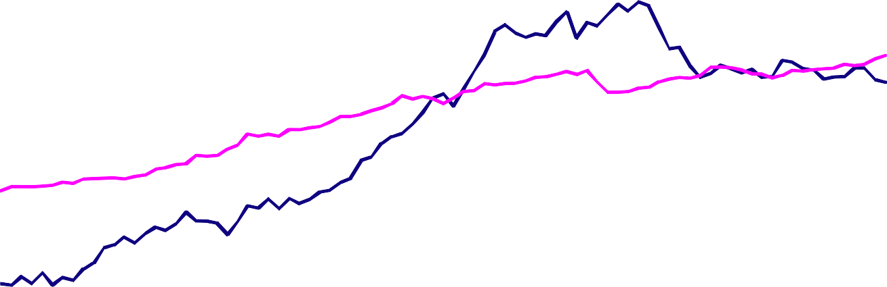

Whole-economy (ex-finance)

110

100

90

80

70

60

50

40

1994 1997 2000 2003 2006 2009 2012 2015

Source: ONS; Bank calculations.

# Efficiency of Financial System

US Finance Income and Intermediated Assets over GDP

US Unit Cost of Financial Intermediation

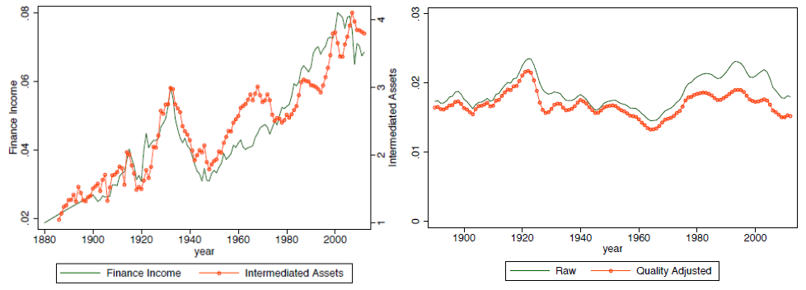

Source: Philippon (2014), “*Has the U.S. Finance Industry Become Less Efficient? On the Theory and Measurement of Financial Intermediation*”.

# Democracy of Finance

World population with a bank account Adults without an account by region, 2014

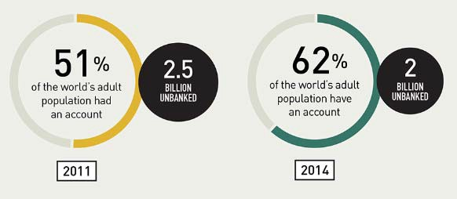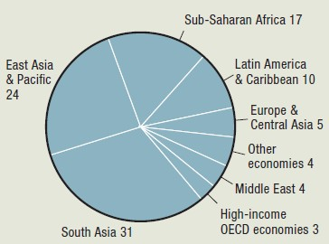

* Around 2 billion adults worldwide without a bank account.
* 10 million US households, and 1.5 million UK adults are also unbanked.

Sources: World Bank Global Findex Database; US Federal Deposit Insurance Corporation (2013); UK Financial Inclusion Annual Monitoring Report (2015).

# Future Of Finance?

## “Payments”

* + Lending
  + Insurance

**Payments Architecture – “Spaghetti Junction”**

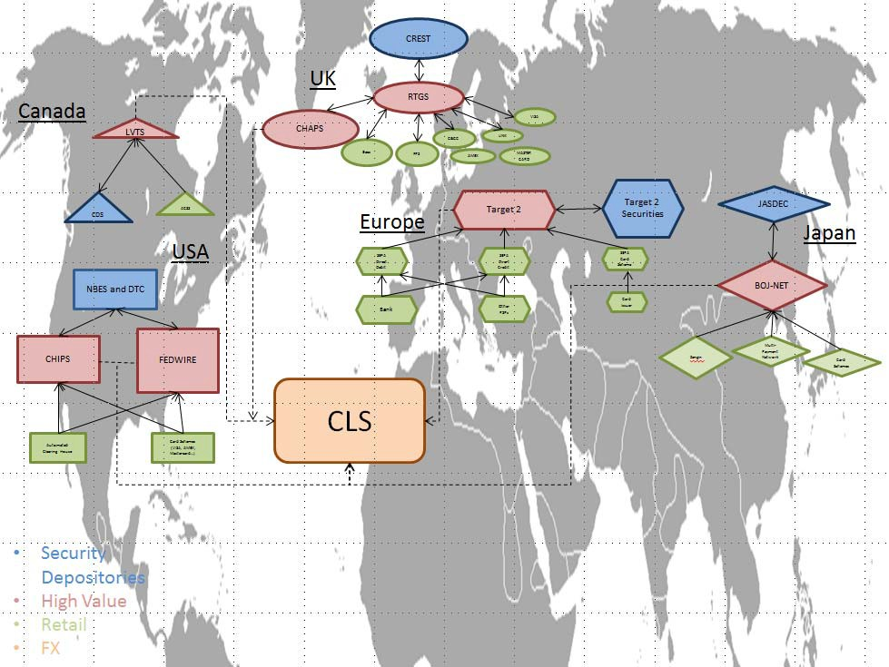

17

**Payments as a Source of Profit**

Payments Revenue to Banks

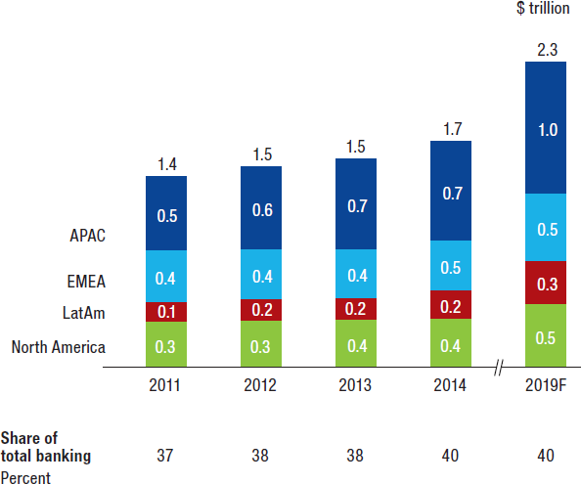

Source: McKinsey (2015), “*Global Payments 2015: A Healthy Industry Confronts Disruption*”.

# Three Models of Payments

Separate Ledgers

Central Ledger

Distributed Ledger

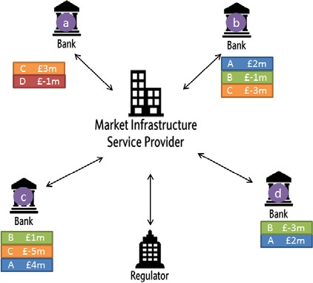 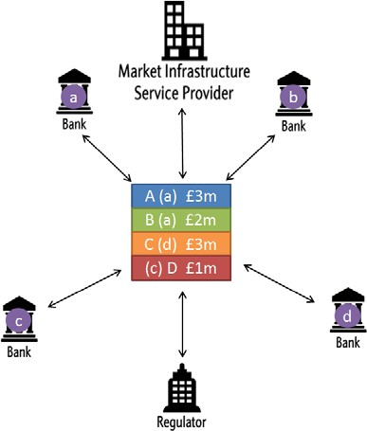 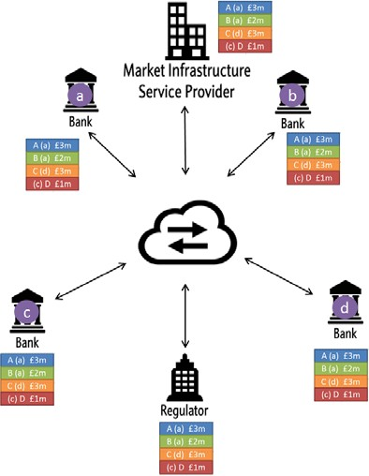

* Common ledger: “money is memory” (Kocherlakota (1996)).

# Opportunities and Threats

### “Smart contracts” – money, payments, FX, commodities, etc?

* Common standards/language – interoperability, lessons from the web?
* Cyber risks – greater or lesser?
* Privacy - public v private goods, open v closed networks?
* Digital currencies - private or public?

**Real World Examples**

* + Payments/money – Coinbase, PayPal, Circle, M-Pesa
  + Securities – ASX with Digital Asset Holding, SETL
  + FX – Stellar, TransferWise, Ripple
  + Derivatives – US Commodity Futures Trading Commission
  + Invoicing – IDA Singapore with Ripple and Standard Chartered
  + Commodities – itBit, GFT
  + Equities - NASDAQ

**The Existing Architecture of Lending**

**29%**

B6

Non-B6

<1% B6 loans

Non-B6 loans Bonds

**16%**

**32%**

**37%**

**16%**

**71%**

Asset finance and ICPFs

Alternative sources

Total stock of bank lending (secured and unsecured) to **households**

Source: Bank of England.

Total stock of debt to **businesses**

Sources: ABFA, FLA, Nesta, ONS, Bank of England. Notes: Non seasonally adjusted. Share in the stock. Data are to end-December 2015, with the exception of Bonds and ICPFs which are to end-September 2015. Excludes equity finance. Alternative sources includes Peer to Peer finance and crowdfunding.

# Growth of P2P

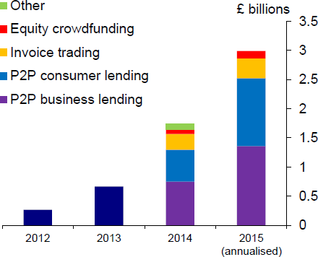

Source: NESTA for 2012-2014; AltFi Liberum Volume Index UK for 2015 (data to 12 October). Notes: See McCafferty (2015), “*UK business finance since the crisis – moving to a new normal?*” for further details.

# Opportunities and Threats

### Can critical mass be attained? Bad apple risks

* + P2P v “Handelsbanken” model? Hard v soft data
  + How “alternative” is alternative finance?
  + Information barriers to entry - credit registers and Big Data?
  + Regulation of new banks and non-banks
    - when is there a systemic threat?

**Insurance Industry**

* + Car insurance
  + Health/Life insurance

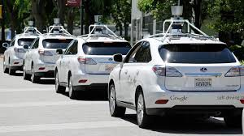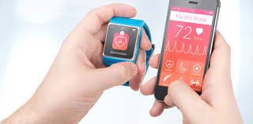

**Driverless Cars**

* + In 2020, Google plans to launch a self-driving car which:
    - has already driven nearly one million miles
    - doesn’t get tired and irritable
    - doesn’t swerve into lamp posts or require a driving test
    - has an in-built chauffeur - in the form of a rotating laser taking 1.3 million recordings per second
    - can drive better than you!

### Will anyone own a car in future?

* + - Reduced car demand through pooling?

### By eliminating the element of human blunders, driverless cars are forecast to reduce motor accidents by up to 90%.

Source: Bank Underground (2015), “*Driverless Cars: Insurers Cannot be Asleep at the Wheel*”.

# Impact on Car Insurance Market

### 90% fall in premiums?

* Impact on distribution of premiums - equalise quotes across ages/genders/risk types?
* Insurance for car companies rather than drivers?
* How to deal with cyber-security issues?
* Important legal implications for liability – who to blame when/if there is a crash?

**Health/Life Insurance and Big Data**

* + Can Big Data make inroads into adverse selection and moral hazard problems?
  + Telematics **-** more information from customers’ wearable devices
    - 63% of insurer executives believe wearable technologies will be adopted broadly by the insurance industry by 2017 [*Accenture (2015)]*
    - But less than 1 in 4 consumers are willing to share their health information [*PWC (2014)*]
  + Calibrating existing insurance risk models with richer human behaviour data
    - Tailored premiums by tracking lifestyle habits and social networks?
  + Improved ability to detect fraud by mining unstructured Big Data?
    - For example anomaly detection, developing predictive models, network analysis to facilitate effective investigations.
  + Re-evaluating individual risk vs risk pooling. If you could perfectly predict health outcomes from DNA data, would everyone self-insure?

# Conclusion

### …. Finance Version 2.0?

…. time to remove the question mark? ….